School of Computer Science and Artificial Intelligence

Lab Assignment # 2

Name of Student : Thakur Phani Kumar
Enrollment No. : 2303A51529
Batch No. : 22

Task 1: Cleaning Sensor Data
❖ Scenario:You are cleaning IoT sensor data where negative values are invalid.
❖ Task:Use Gemini in Colab to generate a function that filters out all negative
numbers from a list.
❖ Expected Output:
➢ Before/after list
➢ Screenshot of Colab execution

Prompt:-
write a Python function filter non negative that returns a new list with only values greater than or equal to 0, without modifying the original list, for cleaning invalid negative IoT sensor readings.

Code:-
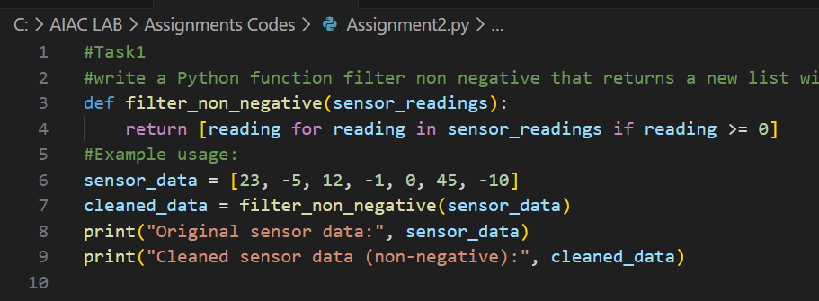

Output:-
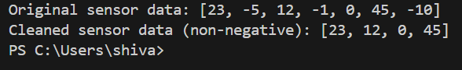

Justification:-
This function uses a list comprehension to create a new list that includes only the non-negative values from the original list. It does not modify the original
list,ensuring that the raw sensor data remains intact for any further analysis or processing.

Task 2: String Character Analysis
❖ Scenario:
You are building a text-analysis feature.
❖ Task:
Use Gemini to generate a Python function that counts vowels, consonants,
and digits in a string.
❖ Expected Output:
➢ Working function
➢ Sample inputs and outputs

Prompt:-
write a friendly Python function that takes a text string and returns how many vowels, consonants, and digits it contains, treating upper and lower case letters the same.

Code:-
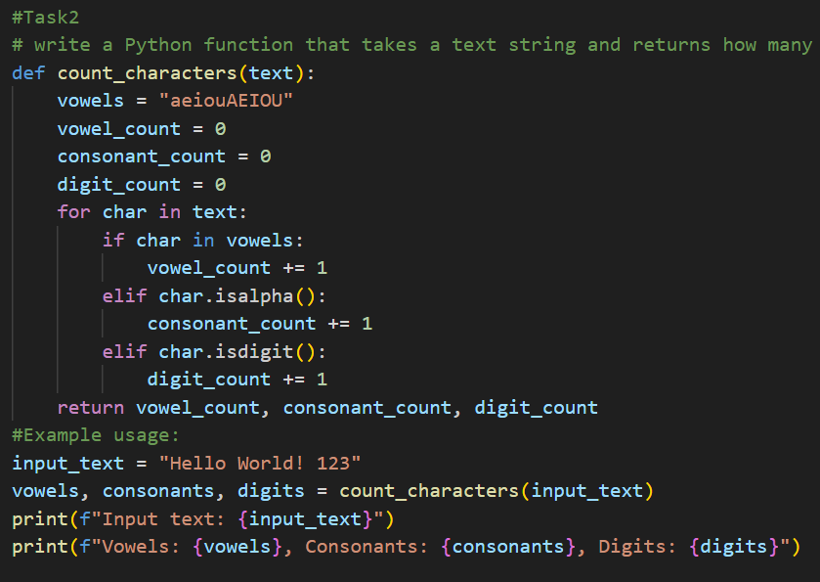

Output:-
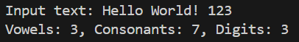

Justification:-This function iterates through each character in the input string, checking if it is a vowel, consonant, or digit, and increments the respective

counters accordingly. It treats upper and lower case letters the same by including both in the vowels string and using isalpha() for consonants.

Task 3: Palindrome Check – Tool Comparison
❖ Scenario:
You must decide which AI tool is clearer for string logic.
❖ Task:
Generate a palindrome-checking function using Gemini and Copilot, then
compare the results.
❖ Expected Output:
➢ Side-by-side code comparison
➢ Observations on clarity and structure

Prompt:-
write a simple, readable Python function is palindrome that returns True if a string reads the same forwards and backwards ignoring case and spaces and False otherwise.

Code:-
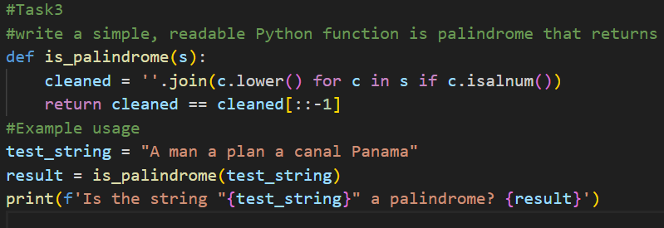

Output:-

Justification:-
This function is simple and readable because it breaks down the problem into clear steps: cleaning the string by removing non-alphanumeric characters and converting to lowercase, then checking if the cleaned string is equal to its reverse. This makes it easy for beginners to understand how palindromes work.

Task 4: Code Explanation Using AI
❖ Scenario:
You are reviewing unfamiliar code written by another developer.
❖ Task:
Ask Gemini to explain a Python function (prime check OR palindrome
check) line by line.
❖ Expected Output:
➢ Code snippet
➢ AI explanation
➢ Student comments on understanding

Prompt:-
Python function either a prime checker or palindrome checker and explain it line by line in simple, student friendly language, as if teaching a beginner.

Code:-
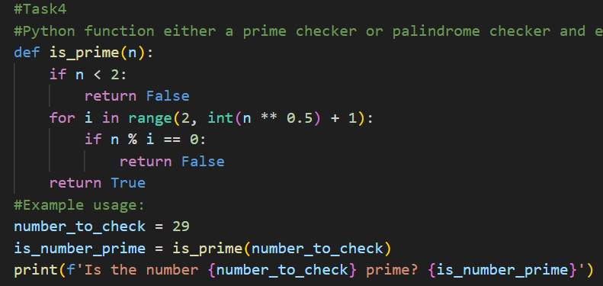

Output:-
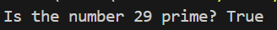

Justification:-
The function checks if a number is prime by first handling numbers less than 2 (which are not prime). Then it iterates from 2 up to the square root of the number, checking for divisibility. If any divisor is found, it returns False; otherwise, it returns True.

